Module 5: Scientific Investigations
Outcomes
A student:
- develops and evaluates questions and hypotheses for scientific investigation INS11/12-1
- designs and evaluates investigations in order to obtain primary and secondary data and information INS11/12-2
- conducts investigations to collect valid and reliable primary and secondary data and information INS11/12-3
- develops and evaluates the process of undertaking scientific investigations INS12-12
Related Life Skills outcomes: SCLS6-1, SCLS6-2, SCLS6-3, SCLS6-11
Content Focus
Students learn that the experimental method is a dynamic process influenced by initial observations, new evidence, unexpected results or phenomena arising from the investigation. They examine the interrelated roles of practical and secondary-sourced investigations. When conducting practical and secondary-sourced investigations, students use peer feedback to refine their investigative designs and report on their findings.

Students explore the importance of accuracy, validity and reliability in relation to the investigative work of a scientist. They examine the differences between a scientific investigation and a scientific report, recognising that although the report format follows a sequential order, the investigation need not.

Working Scientifically
In this module, students focus on: developing and evaluating hypotheses and questions; designing and evaluating investigations; and undertaking valid scientific investigations. Students should be provided with opportunities to engage with all Working Scientifically skills throughout the course.

Content
Practical Investigations to Obtain Primary Data
Inquiry question: What initiates an investigation?

Students:
- research the factors that led scientists to investigate the following, including but not limited to:
  - peptic ulcers (Marshall and Warren)
  - plant growth (Von Helmont)
  - microwaves (Spencer)
- propose a reason for the scientists undertaking their investigations above by examining the type of data or information that they sought, for example:
  - finding relationships or patterns in identified phenomena
  - testing the conclusion of a previous investigation
  - utilising scientific knowledge and understanding to make more accurate predictions and develop new technologies
- determine the hypotheses that were tested in each of the scientific investigations above
- describe where deviations from the traditional and linear models of scientific methodology were necessary in order to test each hypothesis in the investigations above

Scientific Investigations: A process
- Observer ponders a question about a phenomenon or event
- Creates hypothesis
- Collects evidence from primary or secondary data
- Reports the analysis and conclusion for peer review

- Does not have to follow this protocol but must be structured in a format that the scientific community understands
- Scientists can build on existing ideas, theories and knowledge in an orderly manner.
- However, ideas thought to be true for hundreds or thousands of years can be overturned by brand-new ideas. Scientific discoveries can be made by accident or by extraordinary methods

Scientific investigation – an organised approach to solving a scientific question i.e. a cycle of findings, refining, questioning and analysing data

Investigation investigated in many ways:
- Asking questions
- Sudden flash of inspiration pushing new ways of thinking about a problem
- Taking risks

Scientific theory – an explanation of an aspect of the world that can be tested

Discoveries:
- Come from taking ideas and discoveries made in the past
- Exploring new aspects of these ideas
- Develop new ideas when technological advances allow more accurate or fresh observations
- E.g. atomic theory developed because new technology was able to show an aspect of the structure of the atom that could not be previously observed.

Peptic Ulcers – Marshall and Warren
- Chronic (an illness that continually re-appears or is experienced for a long time) problem in western civilisation in 20th century affecting the stomach
- Peptic Ulcer:
  - break in the tissue that lines the gastrointestinal tract, mainly in stomach
  - gastrointestinal tract – organ system the mouth to the anus which is involved in digestion of nutrients and excretion of nutrients and excretion of waste products
  - causes great discomfort and pain in the chest and abdominal area
  - other symptoms include vomiting, severe flatulence, nausea and fatigue.

Factors that led to discovery:
- Earlier assumptions: (prior understanding)
  - Ulcers were assumed to be caused by spicy food, stress, smoking and heavy drinking which increased the acid levels in the stomach.
  - Thought that if the acid levels built up too much it would eat away the mucous that lines the stomach and then attack the lining of the stomach
- Doctors thought it was impossible for any bacteria to survive in the highly acidic environment of the stomach

Relationships and patterns:
- Marshall and Warren studied biopsies (tissue sample with needle used to test cells) of patients of severe ulcers and found the bacterium – Heliobacter pylori in 1979
- Tissue cultures (groups of living cells grown under elaborate conditions) they attempted to grow all failed and it was not till until one of the cultures were left over an Easter long weekend were they successful
- Laboratory technician would check the sample after 2 days and see no growth assuming the culture had failed but giving the cultures 5 days during the long weekend it started growing and extensive experimentation was now viable

Testing Conclusions
- By 1985 Marshall and Warren were frustrated because so one in the medical community took them seriously
- Could not use lab mice in studies with H. pylori because it only affects primates
- Laws against experimenting on people and Marshall grew desperate and he ran the experiment on himself, the only human patient he could ethically recruit so took the H. pylori form the gut of an ailing patient
- Later he developed gastitus, the precursor to an ulcer: committing, stinky breath and feeling sick and exhausted
- Biopsied own gut, culturing H. pylori and proving unequivocally that bacteria were the underlying cause of ulcers

New ideas and technologies
- Despite the evidence, it took over a decade for it to be accepted and for antibiotics to become recommended treatment for stomach ulcers

Traditions method of treatment: | New method and technologies
- Many drugs treated the condition be reducing the production of acid by neutralising it  - It was ongoing treatment to prevent it from returning and hence costly  - Detection by internal examination, biopsies  - Stay in hospital was needed | - Antibiotic treatment completely removed H pylori bacteria from the body  - No further treatment was required  - Significantly cheaper  - Can be detected easily by breath test  - No hospital stay

Tissue culture – a biological tool
- Embryonic Stem (ES) cells are a collection of cells found in early development stage which are the precursors to all other cell type (Somatic SC) in the body
- Somatic cells are of specific types with unique characteristics and functions e.g. Muscle, bone, neuron etc. They have a finite lifespan and are not interchangeable
- ES cells can be induced to change or differentiate into any cell type. They can grow indefinitely in culture. These two unique characteristics make ES cells highly valuable to medicine and science

Growing plants – van Helmont
Plants are a fundamental part of many ecosystems and are the start of most food webs and a source of food

Factors that led to discovery:
- Earlier assumptions: (prior understanding): prevailing theory at the time
  - Plants grew from seeds
  - Grew by eating soil
- Early 1600s, Jan Baptist van Helmont:
  - a Belgian doctor and chemist
  - First to use the term gas
  - researched the ways gases moved and interacted
- Was curious to know how plants grew from seemingly nothing and from where did they get their mass.
- Took a young small willow seedling, put it in a pot with soil and let it grow.
- Only water was added
- Carefully measurements of the mass of the soil and willow plant were taken
- Loss in mass of soil = 57 grams
- Gain in mass of plant > 74kg
- Concluded that the loss of soil of 57 grams over 5 years was an insignificant amount and the growth of the plant can only be attributed to water

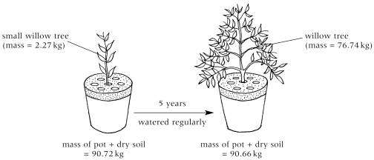

Relationships and Patterns
- Van Helmont tried to manage the relationships between the variables:
  - Dried the soil before weighing it – observed no significant change
- Plant mass was significantly different – 76 kilograms heavier
- Only one plant – hence no patterns
- Not enough background knowledge – process of photosynthesis, role of atmospheric gases in the plant growth were not known
- He had done some work on CO2 – ‘gas sylvestre’ (took almost 100 years before the idea of gaseous exchange in plants was discovered.)
- Could not establish any correct relationship between loss of soil, addition of water and the growth of plant

Testing conclusions
- Conclusion was wrong – the growth of the plant can only be attributed to water and that the soil had nothing to do with it.
- Experiment was invalid – using 1 plant
- Established further areas for botanists to explore

New ideas and conclusions
- In 1727, the botanist Stephens Hales built on Helmont’s work in his book ‘Vegetables Staticks’ in which he discussed about gaseous exchange in plants through transpiration
  - Transpiration: process by which moisture is carried through plants from roots to small pores on the waterside of leaves, where it changes to vapor and is released to atmosphere, evaporation of water form plant
- Researchers determined that soil was very significant to the growth of plants:
  - Included elements sulphur, nitrogen and potassium were essential for the healthy growth
  - Modern idea of fertilisers being used in agriculture: Compounds such as phosphates and nitrates could also help plants grow when added to soil.

Microwave ovens - Percy Spencer
- Microwaves causes water molecules in the food to vibrate to provide a quick and convenient way to heat food
- As the rate of vibration increases the water molecules bump into each more causing friction between the molecules, generating heat
- The food does not absorb the microwaves but let the microwaves travel directly through it making the molecules inside it vibrate more quickly and losing less energy
- Better than stove or conventional oven that uses radiant heat as it generates large amount of heat using more energy, which is transferred to a pot, pan or tray then again transferred to the food. Each step, a good proportion of energy and heat is lost to the environment

Factors that led to discovery:
- American physicist and inventor Percy Spencer (1894-1970) worked with technology developed during WWII
- US military developing radar: RAdio Detection(direction) And Ranging – system used to detect the presence of objects over long distances
- Became an expert in designing magnetrons – vacuum tubes that generate microwaves and are the basis of how radar works
- While working with magnetrons, he noticed that the chocolate bar in his pocket started to melt

Relationships and Patterns and testing conclusions
- Spencer and his friends started to expose various foods to the microwaves, including world’s first microwaved popcorn. Strength of magnetron meant the corn kernels popped almost immediately when exposed to the radiation

New ideas and technology
- He created small metallic box into which electromagnetic radiation could be directed
- Took about 20 years for an appliance similar to modern microwave to go on sale - late 1960’s

Different Types of Scientific Investigations
Inquiry question: What type of methodology best suits a scientific investigation?

Students:
- using examples, evaluate the objectives and data collected in an investigation by a recognised scientist or team of scientists, including but not limited to:
  - Marshall and Warren and peptic ulcers
  - Eratosthenes and Earth’s circumference
  - Doppler and the Doppler effect
  - Priestley’s experiments with oxygen

When scientists start an investigation they need careful planning on how they are going to test ideas and select a suitable method

Eratosthenes and Earth’s circumference
Eratosthenes:
- Born 276 BCE ancient Greek astronomer and mathematician
- First to use the term Geography, invented the system of longitude and latitude, map of the world
- Invented system of finding prime numbers
- First to calculate the distance of Earth from the Moon and from the sun
- Most lasting achievement: remarkably accurate calculation of Earth’s circumference

Work with Earth’s circumference:
- On summer solstice (longest day of the year) – between June 20th and 22nd in the Egyptian City of Syene on noon, the sun was directly overhead as there were no shadows on the ground
- Sun rays were illuminating on the water at the bottom, not the sides of the well.
- At the same time, he measured the angle of the sun’s rays to be 7.2 degrees using the shadow of the pole
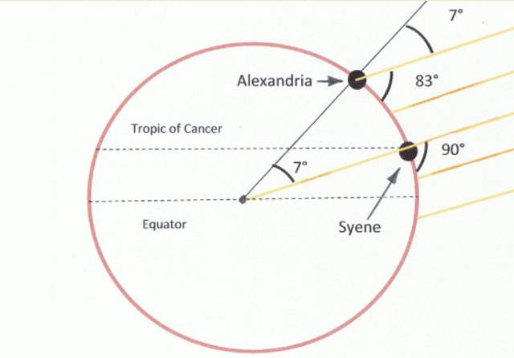
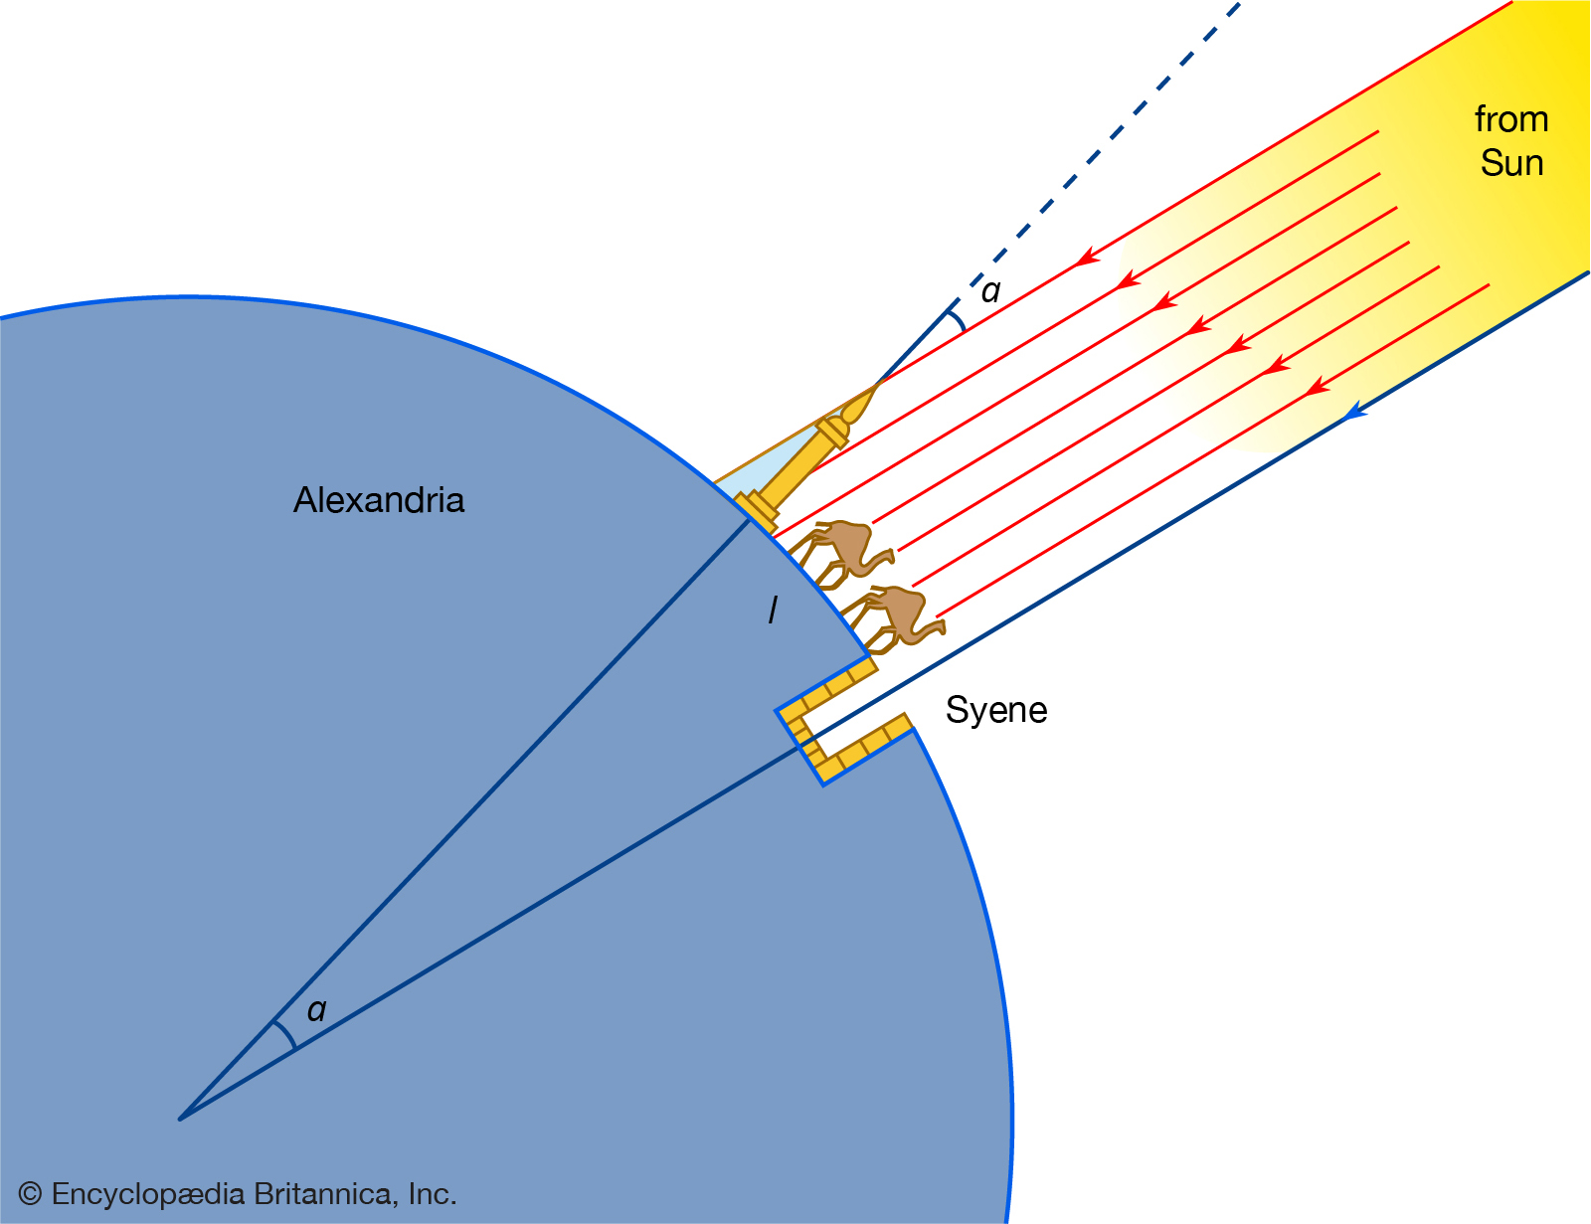

- He knew:
  - The circumference of the Earth makes an angle of 360 degrees
  - Distance between the Alexandria and Syene roughly 800 km through secondary research of asking travellers
  - Alternate and corresponding angles near and right-angled trigonometry
- Set up equation:

360/7.2 = circumference of the earth/distance between Alexandria and Syene

Calculated circumference = 40,000 km, actual value 40,075 km

Doppler and the Doppler effect

Prior knowledge:
- the existence of sound waves
- a sound's pitch is a function of frequency, the closer the waves are to one another, the higher the pitch.

Christian Doppler:
- 1842 First to note the change in the frequency of the wave with the motion of the source
- Austrian physicist Christian Doppler noted this phenomenon when he was studying binary stars and the light detected from them:
  - Binary stars are a pair of stars in orbit around each other
  - The images from the stars were exposed to photographic plates that studied carefully and compared to look for any changes – often these differences were very subtle
  - These differences can be used to infer the relative movement of the stars, including other objects they orbited
  - He noticed that the light spectra from the binary stars was affected by their movement – The pattern in the spectrum shifted depending on the direction of the motion of the stars
  - Stars move extremely quickly and as they move they continuously emit light.
  - This emitted light is bunched up increasing its frequency and shortening its wavelength, which takes it to the blue end of the spectrum blue shifted
  - As the star moves away from the Earth the waves spread out more, taking the frequency closer to the red end red shifted
  - Spectral pattern appeared to shift towards red or blue end of the visible light spectrum
  - Spectral pattern when light is viewed through a spectrograph, the parts of the spectrum have distinct spectral lines that represent the various chemical elements

Doppler effect:
- Change in the pitch of a sound that occurs when the source of the sound is moving relative to the listener.
- It occurs because the frequency of the sound waves changes as the source of sound moves closer to or farther from the listener

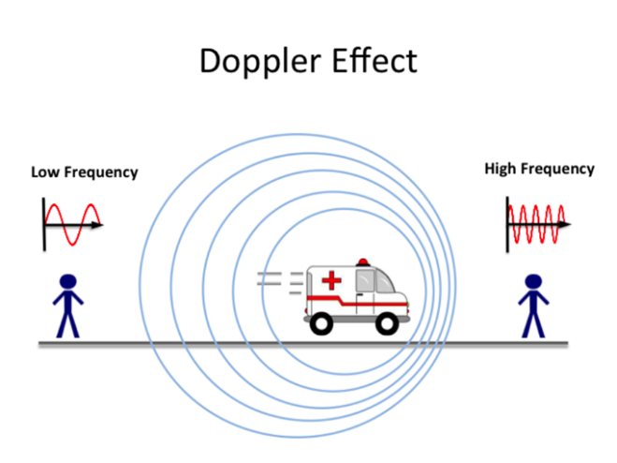
Real world applications:
- Astronomers use it to gauge the movement of stars relative to Earth
  - Idea of red shift allowed Edwin Hubble to use his observation of red-shifting galaxies as evidence for the idea of an expanding universe, and the development of the Big Band theory
- Doppler radar provides information concerning weather patterns:
  - Meteorologists to track storms
  - Detects the direction and velocity of raindrops or hail
  - Determine the motion of winds
  - Allowing predictions of weather patterns that will follow in the next minutes or hours and can indicate coming storms.
- Police use it to measure driving speeds
  - Applying a principle like that used by bats
  - RADAR speed detectors bounce microwave radiation off moving vehicles and detect the reflected waves.
  - These waves are shifted in frequency by the Doppler effect, and the beat frequency between the directed and reflected waves provides a measure of the vehicle speed
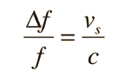
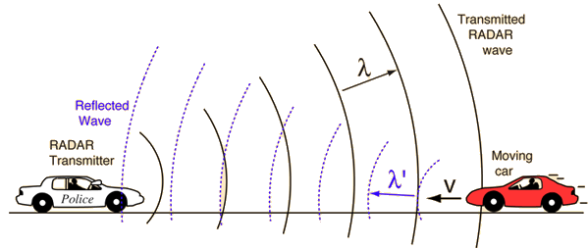
- Doctors even use the Doppler effect to diagnose heart problems
  - Echocardiograms use an ultrasound beam parallel to the blood flow using the Doppler effect to measure: ​
    - The direction of blood flow​
    - Velocity of blood and cardiac tissue at any point​
  - Additionally using this data it can detect: ​
    - Abnormal communications between the left and right side of the heart​
    - Leaking of blood through the valves​
    - Quantitative cardiac output​
  - These are all carried out by using the return frequency of the ultrasound beam to calculate velocity using the Doppler wave equation
If a plane goes supersonic, beyond the speed of sound, the sound waves ahead of the plane bunch up, forming a sonic boom

Joseph Priestley’s experiments with oxygen
Oxygen gas properties and uses:
- Group 6: At number 8
- Mo. Of valence electrons: 6
- Colourless gas
- 21% of atmosphere
- Required for respiration – it helps organisms to release energy by oxidation (combustion) of absorbed food at cellular level
- About half of the earth’s crust combined with silicon

Joseph Priestley 1733-1804
- Discovered oxygen in 1774 when he was trying to investigate why and how things burn
- Gave qualitative explanation of chemical phenomena like combustion, respiration, smelting etc in terms of phlogiston
- In a series of experiments, he found that air contains colourless and highly reactive gas he called dephlogisticated air (it was named oxygen by Lavoisier)
- Many scientists during Priestley’s time tried to determine what elements were and what matter was made of, e.g. chemical composition of air

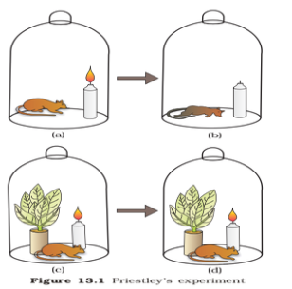
- He had a flame and a mouse in a sealed container
- As time went on, the mouse dies and the flame went out
- concluded the same air that was sustained the flame was also sustain the mouse

- Another experiment he places a live plant in the container with the candle and a mouse
- When the plant was exposed to sunlight it refreshed the air and allowed the candle to continue to burn and the mouse was safe
- Concluded that the plant was refreshing the air
Present understanding – we now know that oxygen is needed for breathing respiration as well as combustion

- He did not know at the time that he just witnesses photosynthesis
- His research let the way for future scientists to investigate this further

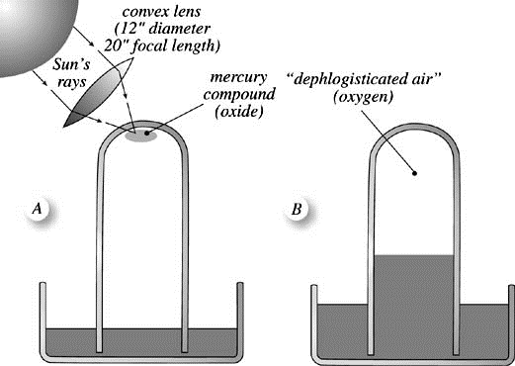
- Using a magnifying glass, he focussed sunlight on a small mass of red mercuric oxide placed in a inverted glass container sitting in the pool of mercury

- Results: Mercuric oxide burned and produced gas
- He found that the emitted gas was 4 or 5 times better than air
- 2HgO -> 2Hg + O2

Further tests:
- Caused flames to burn intensely
- Kept mouse alive for about 4 times as long as similar quantity of air

NEW UNDERSTANDING
Impact of Priestley’s experiments and results:
- Helped dethrone an idea that dominated science for 23 uninterrupted centuries – that air is a “simple elementary substance, indestructible and unalterable”
- Paved the way for other experiments to be done by scientists with more technology to better understand gases
- Led other scientists to look further into the direction as to how plants refresh air i.e. to the process of photosynthesis

- evaluate the methodology of the scientific investigations above by:
  - justifying the method chosen based on the subject of the investigation and the context, for example: experimental testing, fieldwork, locating and using information sources, conducting surveys and using modelling and simulations
  - evaluating the relevance of the investigation by considering the peer-reviewed literature in the area of study
  - justifying the suitability of the type of data that is to be collected

Evaluating Methodology

Methodology – a way of going about an investigation

Primary Investigation – An investigation conducted directly by a scientist. These are the types of investigations most people associate with experiments, where an individual or group conducts the investigation and directly collects and analyses the results. E.g. peptic ulcers by Marshall and Warren

Fieldwork – Where a scientist makes direct observations. Unlike a primary investigation, the observer is not changing the conditions they are observing, merely observing interactions. E.g. Jane Goddall studying chimpanzees

Locating and using information sources – Where a scientist examines the results from another scientist’s experiment. Also known as a second-hand investigation, this is commonly used in areas such as genetics, where large amounts of data can be collated and compared to work out the genes responsible for certain conditions e.g. genetics to collate and compare larger amounts of data

Surveys – Collecting data from a large selections of people. Often used in medical studies to determine potential links between medical conditions and other factors in people’s lives e.g. medical studies to find links for medical conditions

Modelling – A technique whereby an object or phenomenon is represented to show how it works. Simple models include diagrams, such as diagrams of cells, while some complex models replicate the functions of the phenomenon in detail, such as a scale model of a combustion engine. E.g. diagrams, scale models

Simulations – Recreates parts of the phenomenon being studied and allows aspects to be changes. The use of simulations has become more common as computer power and speed has increased. This is a common technique used in areas such as climate modelling

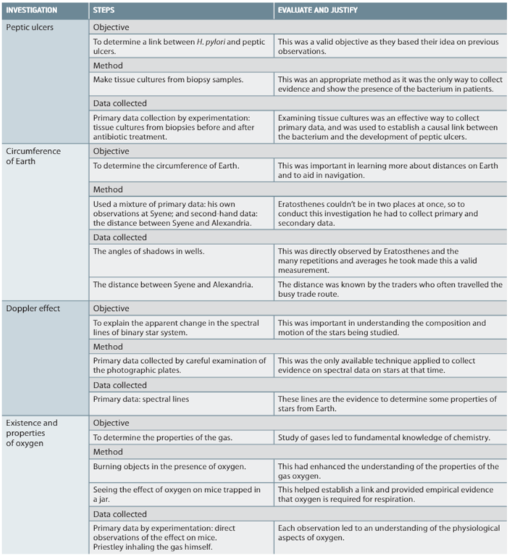

Scientific Method- a process undertaken to answer or explain a question
Steps:
- Make an observation
- Develop a question
- Make a hypothesis
- Design your experiment
- Conduct the experiment
- Accept or reject the hypothesis

Reliability and Validity
Inquiry question: How is the integrity of a scientific investigation judged?

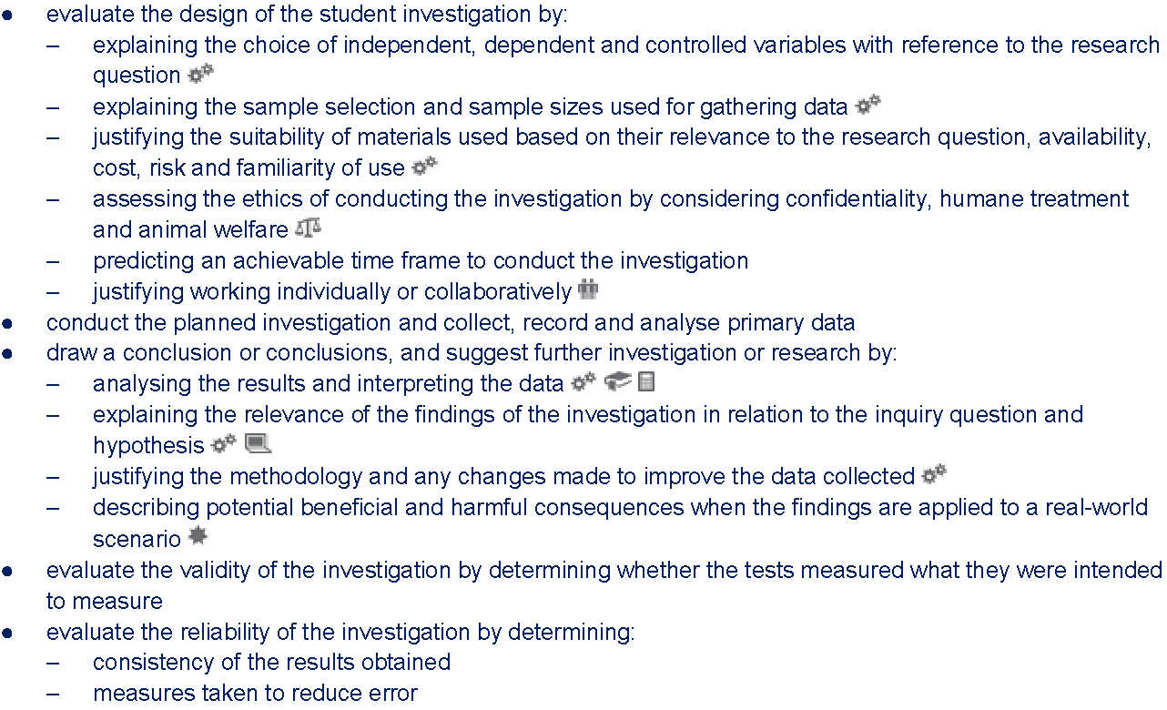

Scientists that do not follow the scientific method when conducting experiments can have false or misleading data.

Validity
For firsthand investigation:
- Determined by fairness of the investigation
- Tests the hypothesis
- Refers to the method and technologies used or chosen
- Ways to ensure validity:
  - Control all variables other than what is being changed – independent variable
  - Choose appropriate technology to collect data

For Secondary sourced research:
- Determined by whether the research is written by an expert in that field
- If it is up to date
- Ways to ensure validity:
  - Ensure the author is recognised
  - Check for most recent research in the field
  - Check if other scientists agree with the research report

Reliability
For firsthand investigation:
- Results would be consistent if the experiment is repeated
- Way to ensure reliability:
  - Conduct more trials repeat many times to get consistent results and reduce error

For Secondary sourced investigation:
- Whether the information is consistent across may resources
- Ways to ensure reliability:
  - Ensure that sources are reputable e.g. from universities or government organisations

Accuracy of Investigations/results
- Determined by careful and correct reading of measurement from equipment
- Correct recording of the measurements taken
- Ways to ensure accuracy:
  - Select appropriate equipment
  - Ensure the equipment is properly calibrated for intended measurement

Variables and controls – help to ensure validity and reliability
- Independent variable: Factor that is deliberately changed
- Dependent variable: Factor that is being measured
- All other factors are controlled
- Controlled variables are important to ensure the validity of the experiments as they allow scientists for focus on the hypothesis

Sampling
- A method used by scientists to collect data by collecting information from a smaller section of a bigger group
- 2 important questions:
  - 1. How much data to collect?
  - 2. How often to collect data?
- E.g. ecological investigations to understand the interactions of species within an environment
- Essential for scientists in this area to understand the environment and can be done by estimating sizes of populations
- Challenges:
  - Time consuming to count each species
  - Animals usually run at the first sign of a potential predator
- Techniques have been developed to look at a section of the environment and then estimate the whole environment based on the sample
- Two of these methods, which are used for non-mobile members of a community (e.g. plant such as trees) are random quadrats and transects

Quadrats
- A quadrat - a process by which a small area, usually 1m^2 to estimate the population of a species within a larger area
- Randomly dropped in the area being examined and the number of species within it are counted.
- $Estimates population= \frac{total number IN quadrants}{total number OF quadrants} × \frac{total area studied}{total area of quadrants}$
- The more quadrants the more accurate the estimation will be

Capture-recapture
- A method to estimate the population size by trapping them in a small area, tagging, releasing them and then extrapolating the total population
- Works well with species that move around.
- It involves setting up traps for animal species.
- The trapped species are tagged and then released.

The cost of science
Important factor when planning any investigation
- Is the equipment you are using easily available?
- Do you need to spend money on any equipment? If it is going to cost too much money you may have to rethink your question
- Is anything in your experiment a large risk? If it is too dangerous, rethink
- Do you know how to use the equipment you need to use for the experiment?

Biggest and most expensive piece of science equipment ever made is the Large Hadron Collider.
- Construction was finished in 2008
- Cost 9 billion US dollars
- Running costs of 1 billion USD per year

Science and ethics
Ethical – whether what is being done conforms to good standards of behaviour
- Will this research help people?
- Will this research cause harm?
- Is the research beneficial

Morals – a judgement about whether what is being done is good or bad

Construction finished on the Large Hadron Collider there was concern that the energies produced, and the unknown areas of particle physics could initiate the creations of unknown entities such as mini black holed
Infinitesimally small chance but some people still argued the potential harm to society was not worth the risk

Peptic ulcers and human trials
Work of Marshall and Warren raised many ethical issues especially when Marshall tested his hypothesis on himself. As a result, it took a long time to accept their research.

Priestley, oxygen and animal testing
- Joseph Priestley used many mice to show the existence of ‘dephlogisticated’ air.
- If research was conducted today, he would be under intense pressure to ensure no undue harm came to the animals in his experiments
- However, during his time, it was acceptable to use animals in research and scientists rarely considered any harmful effects on their test subjects
- Several decades ago, products such as cosmetics were regularly tested on animals such as rabbits and monkeys
- Today many countries have abolished these practices as they are deemed cruel
- ‘Australian code for the care and use of animals for scientific purposes’ is a set of rules that governs the use of animals in science

Timeframes
- Important skill is the ability to predict how long research may take
- Most experiments usually last in the time it takes reactions to occur
- Priestley’s took years to complete

Working alone or in teams
- Many important historical discoveries were made by individuals
- Majority of modern and contemporary science is done collaboratively.
- E.g. Marshall and Warren started individually, with Robin Warren noticing the H pylori on tissue samples, he later started working with Barry Marshall and their teamwork allowed them to progress at a quicker rate
- If you work in a group, then you can use the different skills your team possesses. People have different strengths and weaknesses

Primary and secondary data
Primary data – data you have collected yourself during an investigation

Secondary data – data collected by other people and published sources

Qualitative data – which are data that can be measured by a number e.g. temperature or time

Quantitative data – which is data that cannot be expressed as a number e.g. people’s opinions

Interpreting data
- Data is usually presented in a table to show what the investigation has proved
- Data is easier to interpret if they are converted onto a graph
- Sometimes it is necessary to show multiple data sets on the one graph to compere dependent variables

Explaining your results
- What did your data show?
- Why did this happen?
- Your results may also prompt you to think of new areas of potential research

Did you test what you intended to test?
- Did you test your hypothesis? Important in the aspect of validity
- Were your measurements reliable? Were there errors? These errors could affect your results

Can you improve?
- Reflect on what you have done, could you improve your methodology
- Any investigation should endeavour to collect data that are as accurate your experiment as your experiment will allow
- May be ways to modify your investigation to increase accuracy, validity and reliability
- Important step for scientists to refine experiments and hypotheses

Does the investigation help humanity?
- Company 3M invented many thing people use every day. Most famous innovation is the Post-it Note
- Spencer Silver, a scientist working for 3M was attempting to make an extremely strong adhesive when he developed the slightly sticky adhesive that left minimal residue instead. This slightly sticky adhesive would eventually prove to be more useful
- This example shows that while not every experiment will be revolutionary, they may still have positive implications for society

Reporting
Inquiry question: What is the structure of an investigative report?

Students:
- review a published and peer-reviewed scientific report to determine the conventions of writing a report on a practical investigation
- use a sample of a published and peer-reviewed secondary source to identify:
  - the purpose of the report
  - measures taken to reduce error
  - the language style used
  - the presentation and structure of the report
- compare and contrast the structures and functions of a scientific investigation and its written report
- prepare a report on the student investigation that was carried out

Reporting
- Outline the methodology used, describe the fist-hand data collected and explain how this data was used.
- Other scientists should be able to replicate the investigation if required or clearly understand that data
- Peer review processes ensures that the data and conclusions made are valid and then can be published in a scientific journal

- Abstract – Introduction, inquiry question, background/historical information
- Aim
- Hypothesis between independent and dependent variable, cause and effect, why?
- Materials
- Risk Assessment – Identify risk, rating, minimisation and management
- Procedure, methodology – diagram if necessary
- Results – data: table, graph
- Discussion – trends, analysis, accuracy, reliability, validity, safety risk, identify errors and analysis, improvements, explanation of scientific phenomenon
- Conclusion – describe trend between independent and dependent variable, does it satisfy aim

Investigations and reports

Investigations
- Functions of the investigation is to test a hypothesis
  - Identify your question – what you are going to study
  - Form a hypothesis – what you think the answer to your question will be
  - Conduct your experiment – perform a valid and reliable experiment to answer your question

Reports
- Taking results from the investigation and explain what was found
- May also discuss the background behind the investigation.
- How did the scientists come up with their hypothesis based on work done in the past?
  - Did you answer your question?
  - Did your experiment match your hypothesis?
  - Thoroughly analyse how you conducted your experiment and how you know it is valid and reliable
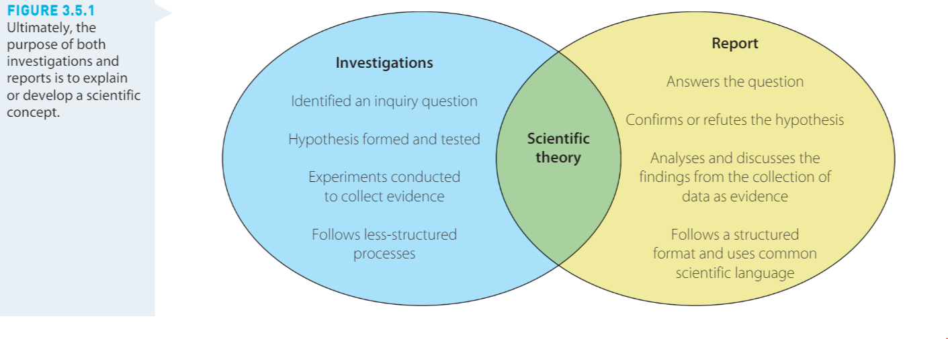

Peer assessment
Aim is to improve scientific methodologies

